**INSTALLATION**

1.- Unzip AC Circuit Lab (ACLab.zip)

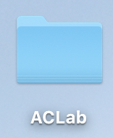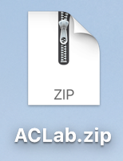



2.- Open ACLab file and Run “Launch ACLab.py”. ( The file should contain ACLib.py, Pmw, Test.py and Launch ACLab.py)

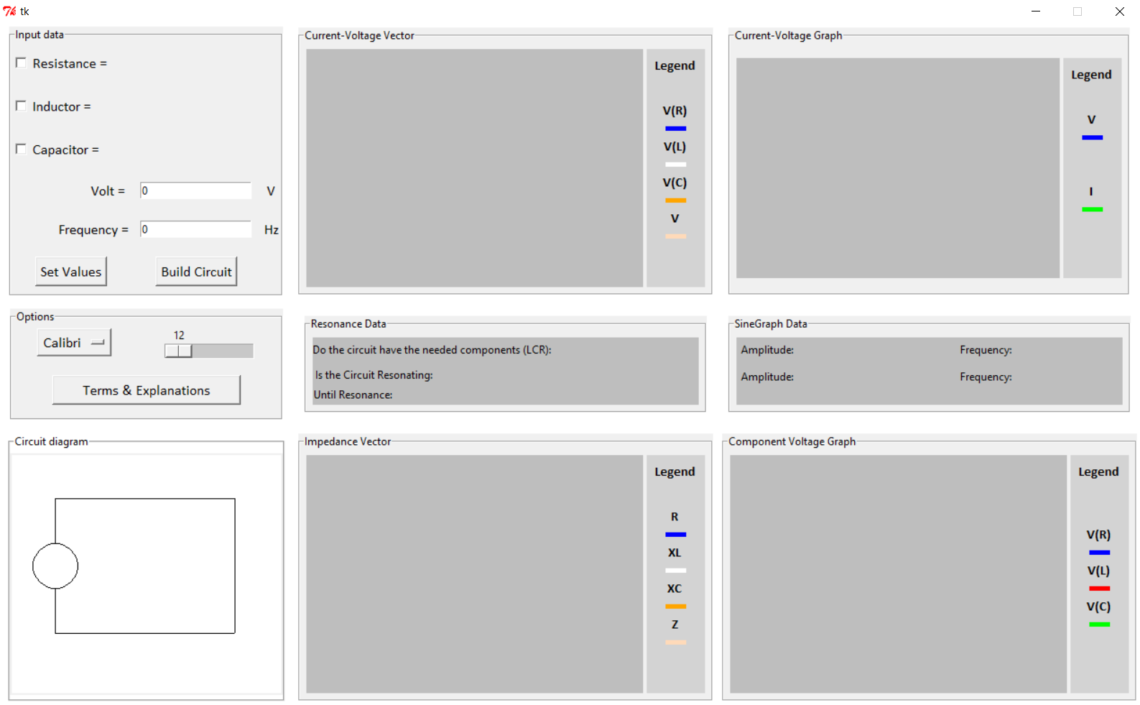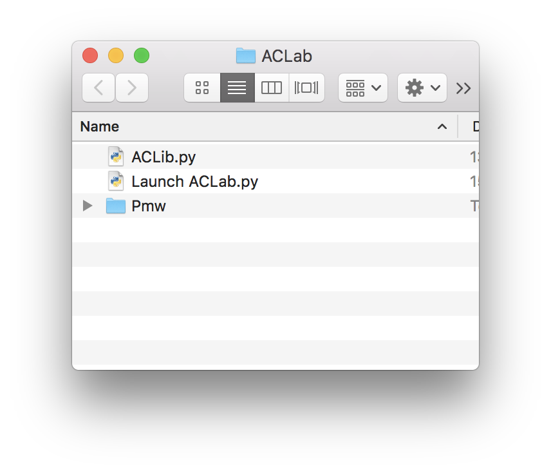



**USER GUIDE**

1.- Click on the checkboxes to add/remove the desired components. Enter desired values of each of the components into the “Input data” frame. Click  and then click.

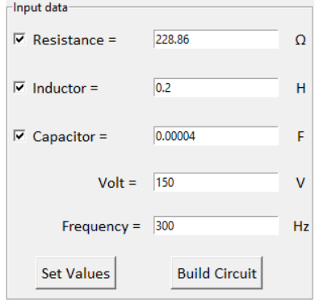

2 - Relevant calculations can be observed on the info page that shows up.

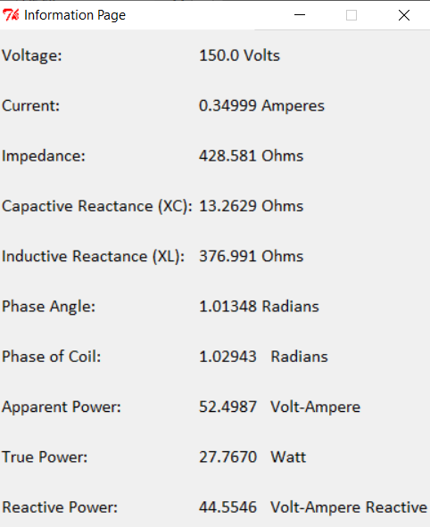

3. Finally the relevant vector diagrams and sinus functions can be observed to the right of the input data box.

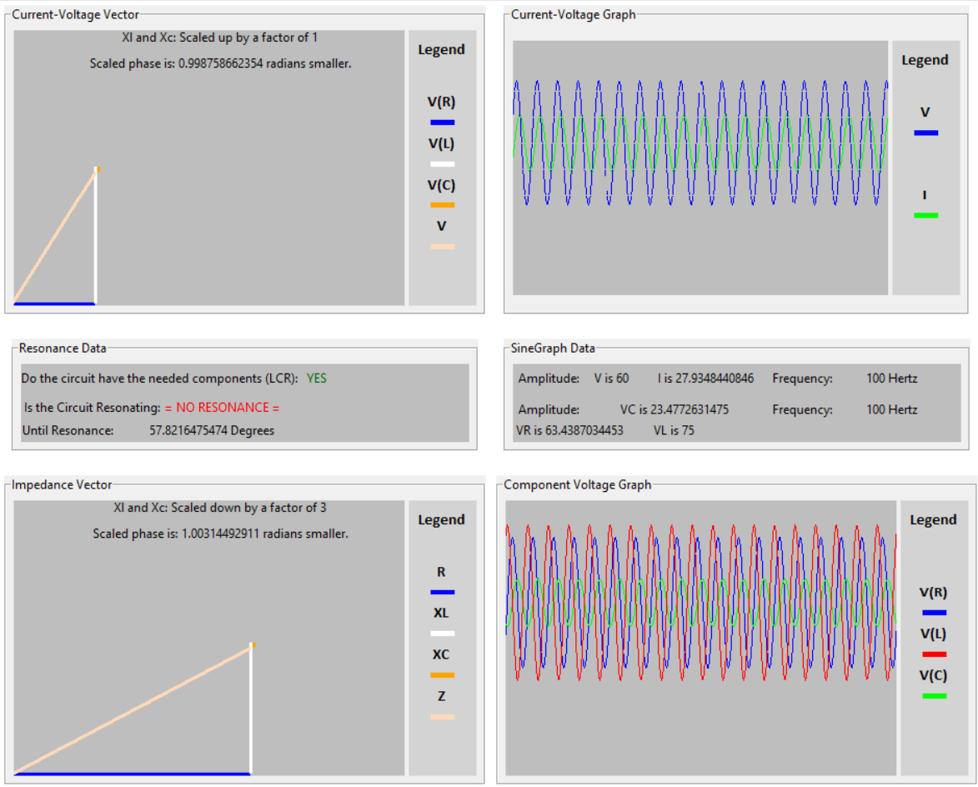

4.- To change font and font size, go to the “Options” frame. To change font type, click on the “Calibri” box to switch to “Comic sans”. To change font size, use the slider right next to the font box.

5- To obtain a better understanding of the physical significance of the numbers and components, click on the “Terms & Explanations” box to read through a brief explanation of the circuit’s components.

